Group 2 Project Plan, Part I

# Project Scope

The scope of this project will include the creation of a desktop version of Baker’s Dozen solitaire game along with all necessary project management documentation.

### Application Description

The game application will feature a playable version of solitaire using the Baker’s Dozen rules. The game will consist of a deck of 52 playing cards (jokers removed) and a game board. The game board will consist of four Foundation areas where the user may place cards as well as a Tableau area consisting of thirteen card piles.

Game features will allow the deck to be shuffled and individual cards to be moved between the different card areas. Other features such as a move counter or a timer may be added to the game as project scheduling allows.

### Project Documentation

Deliverables in this project will submitted in four main areas:

1. Project Planning – Includes this document, the Project Schedule document, and a Software Test Plan document.
2. Requirements - Consists of use cases, a Requirements Specification document, and application prototype.
3. System Design Documents – Includes high-level design information, conceptual system design information, and technical design information
4. Additional Documents – Consists of a Test Specification document, team time sheets, and meeting minutes

# Team Organization

The project team will use a waterfall process. This makes sense as this project will only see one release. This document serves as the first step in the planning stage of the waterfall model. The team will distribute actual work as evenly as possible. Team members will all participate in the creation of project documents as well as the actual programming of the application. For team member information, see the Appendix for team member resumes.

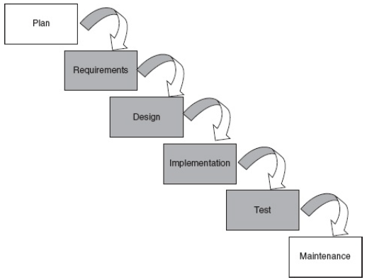

Waterfall Process Model

# Data Management Plan

Data for this project will be housed using GitHub. Managing the data in this way will afford the team four main benefits:

1. Ensure that all data is backed up to an off-site location
2. Ensure that all data is accessible by the team at any time
3. Allow for all changes to documents to be recorded
4. Allow any changes to be rolled back

All members of the team will be granted “collaborator” status on the repository. This will prevent any one person or subset of the team from becoming the bottleneck for project changes. Any time that a change needs to be made to a document any team member can make the change without further input from the team. GitHub’s archiving and recordkeeping tools mentioned above will offer visibility in to each change that has been made as well as the ability to “un-do” changes.

# Appendix – Team Resumes

See following pages.